TERRAFORM TASK 01
- INSTALL TERRAFORM ON YOUR PC
Download Terraform:
  - Go to the official Terraform downloads page: https://developer.hashicorp.com/terraform/install
  - Find the Windows section.
  - Select the link for the This will download a .zip file containing the terraform.exe executable.
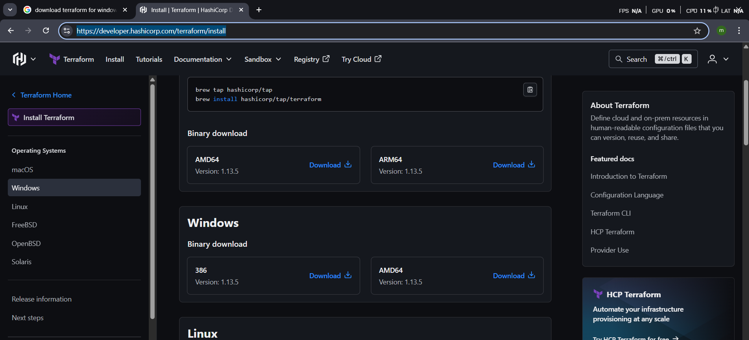
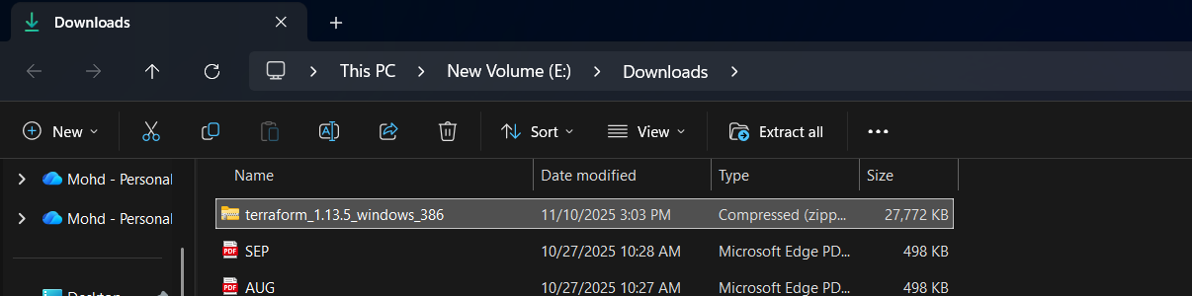
Extract the Executable:
- Locate the downloaded .zip file.
- Extract the contents to a permanent location on your computer. A recommended path is to create a new folder, such as C:\terraform
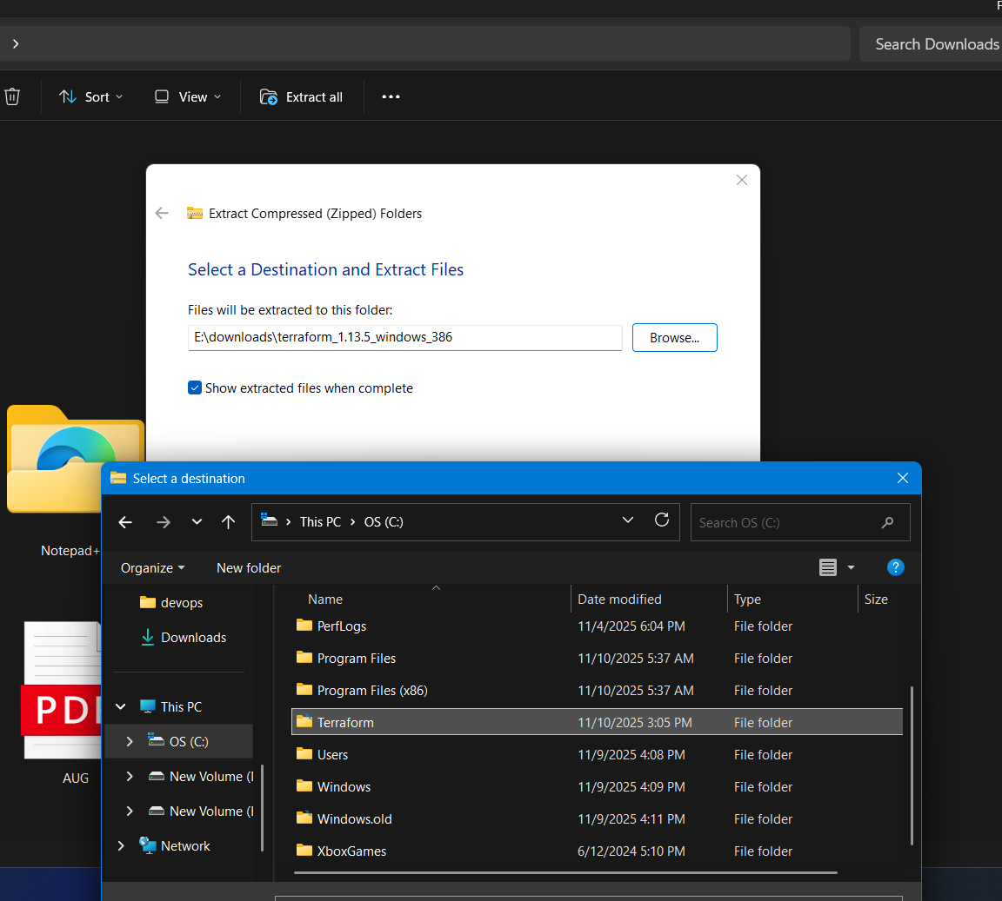
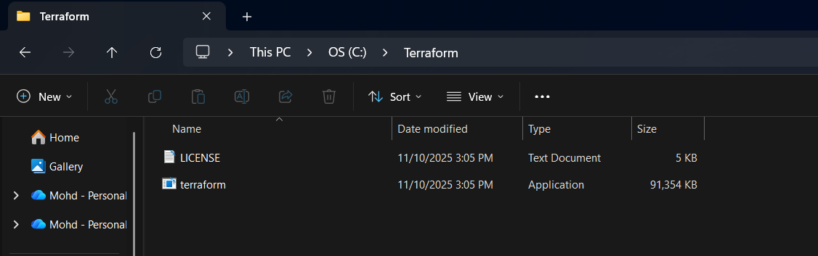
Add Terraform to System PATH:
- Open the Windows Start menu and search for "environment variables".
- Select "Edit the system environment variables".
- In the System Properties window, click the "Environment Variables..." button.
- Under "System variables" (to make it available for all users) or "User variables" (for your account only), select the Path variable and click "Edit...".
- In the "Edit environment variable" window, click "New" and paste the path to your Terraform folder (e.g., C:\terraform).
- Click "OK" on all open windows to apply the changes

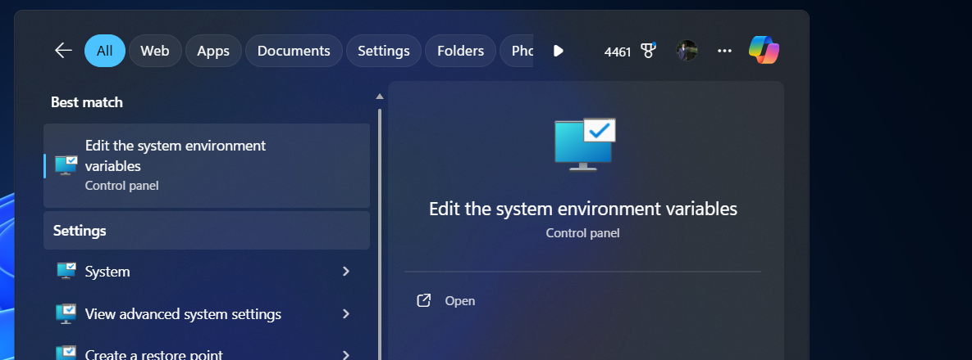
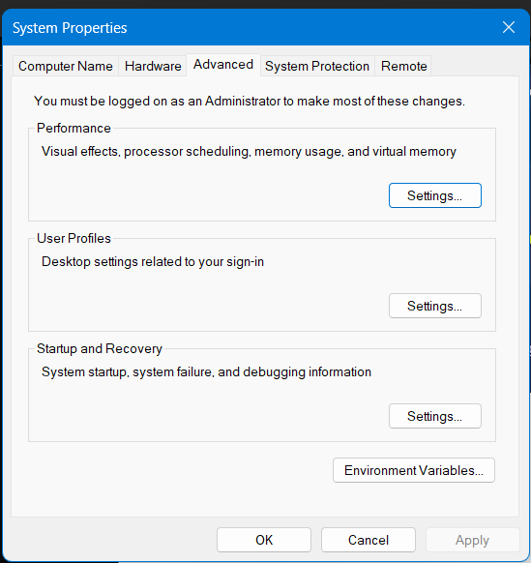
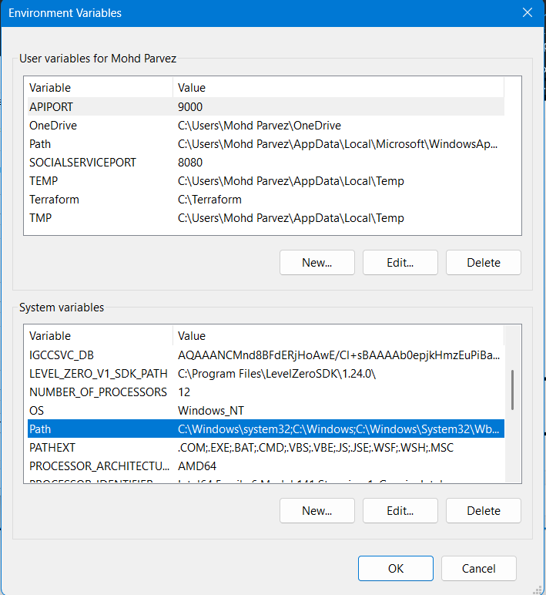
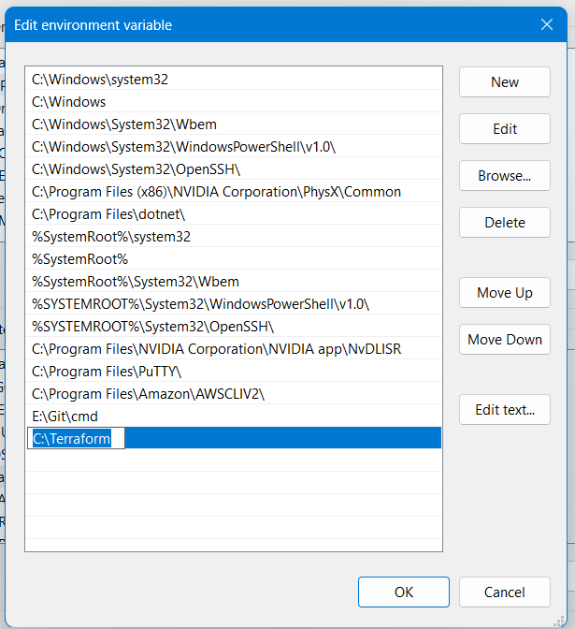
Verify the Installation:
- Open a new Command Prompt or PowerShell window (existing windows may not have the updated PATH).
- Type the following command and press Enter:
bash
terraform -v
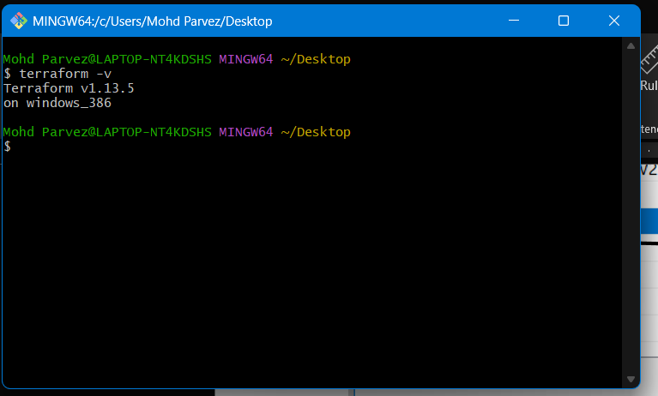
- Download the visual studio from store
- And open
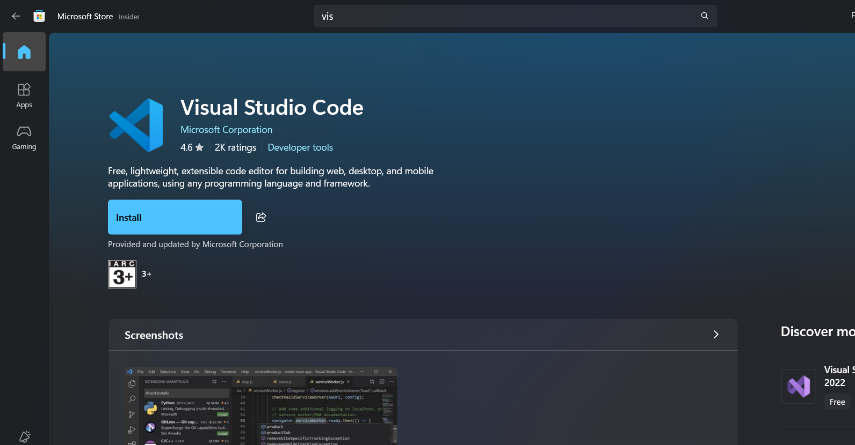

- Download the hashicorp terraform extension
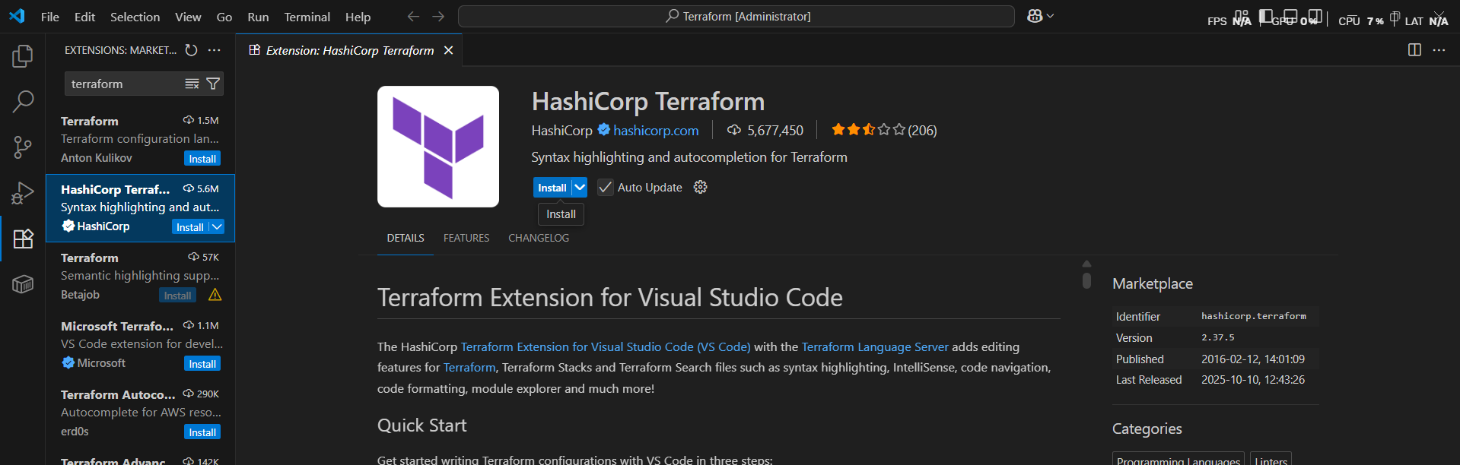

- EXECUTE TEMPLATES SHOWN IN THE VIDEO

- Create a new file with <filename>.tf : “.tf” is the extension for the terraform resource file

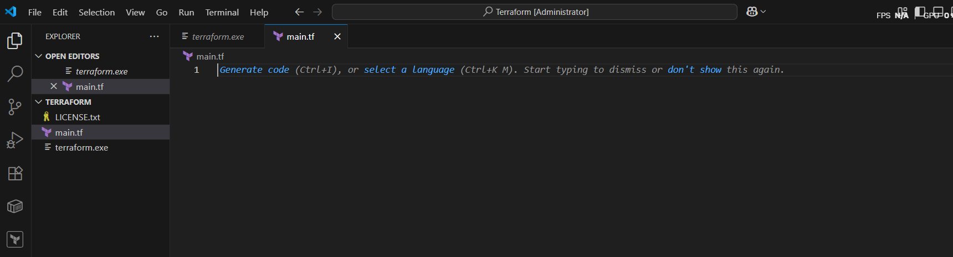
- Write the template
- resource "local_file" "my_pet" {
- filename = "pets.txt"
- content = "i love pets"
- }
- Open the terminal in the visual studio and initialize the terraform in the terminal
- Command : terraform init – we need to have the dependencies installed to execute the local provider
- Terraform provider: is a complete package of ap calls to communicate with our resource
Ex: aws, GCP , Alibaba , oracle etc..
- Api calls : takes request from users and respond to the user
- Resource: block
- Providers: local 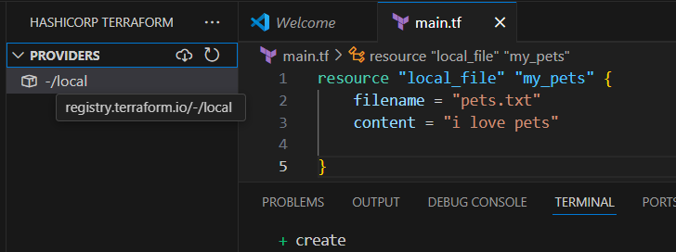
- Type: type of resource
- My_petname of terraform
- File name & content :attributes of the resource
- Use “terraform plan” command : -out line of the code before execution its like a blue print.
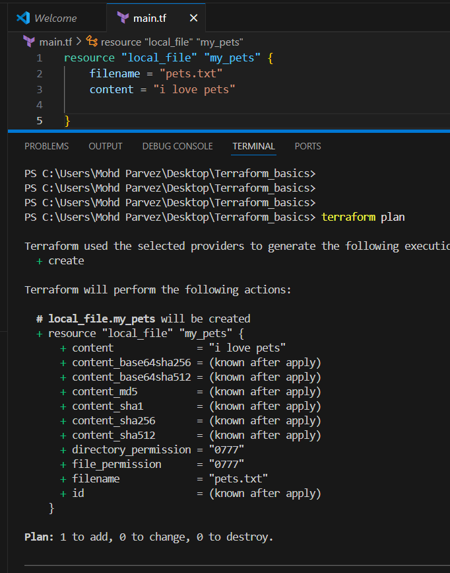

- Use “terraform apply” command :

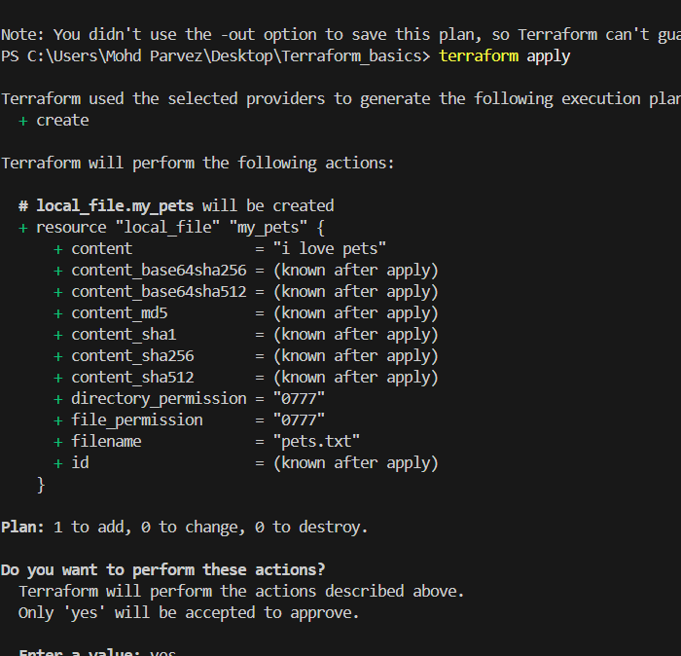
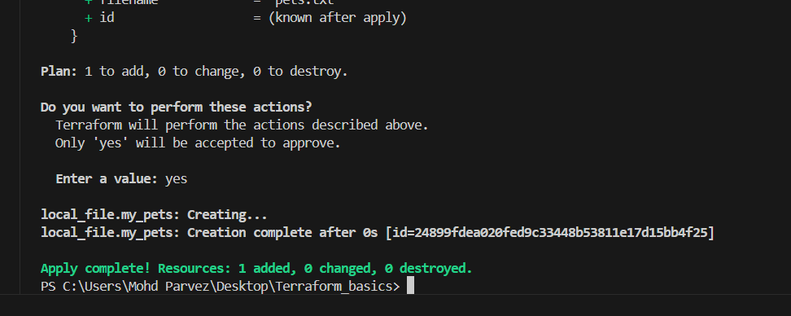
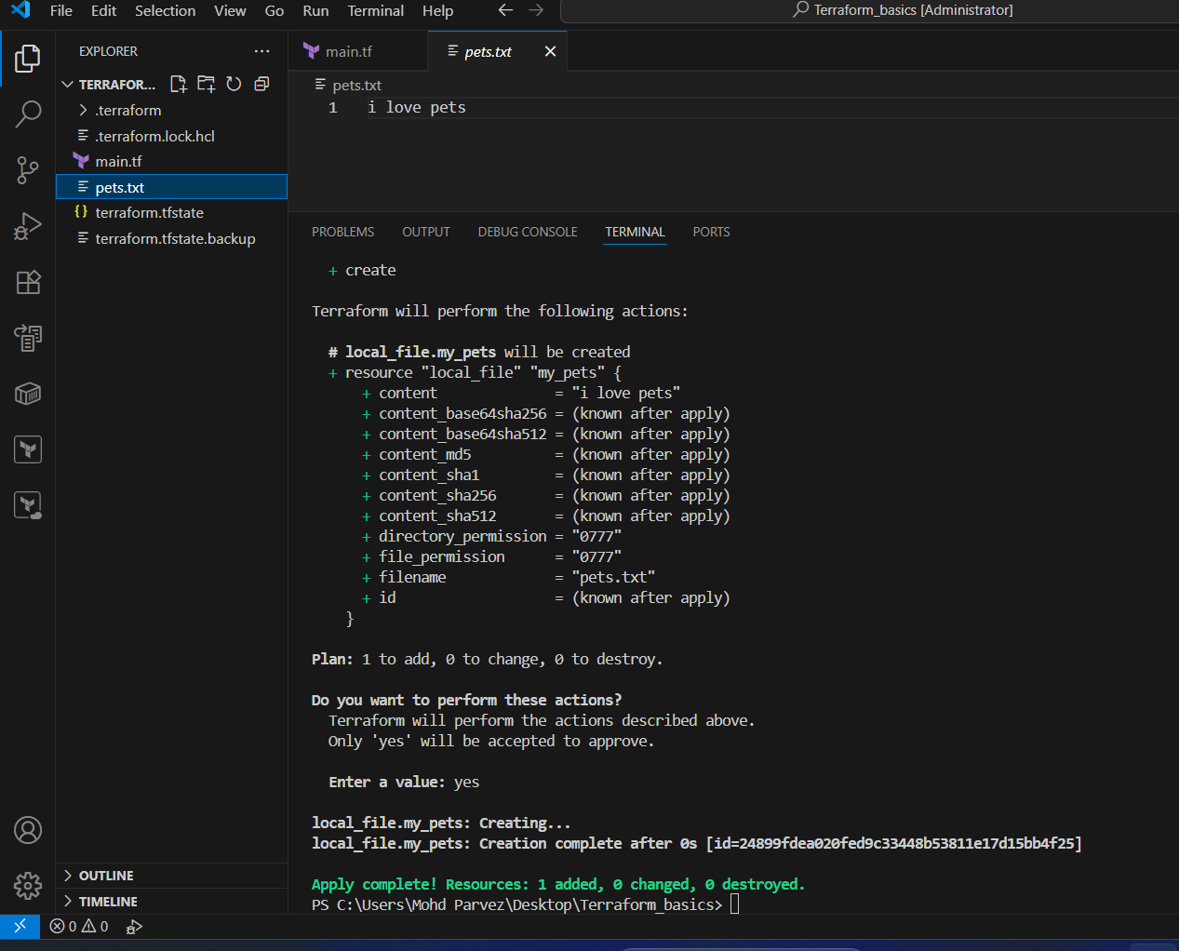
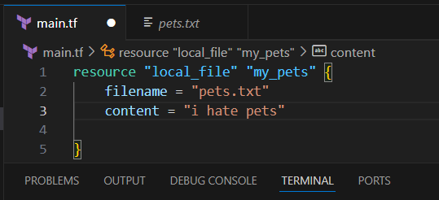
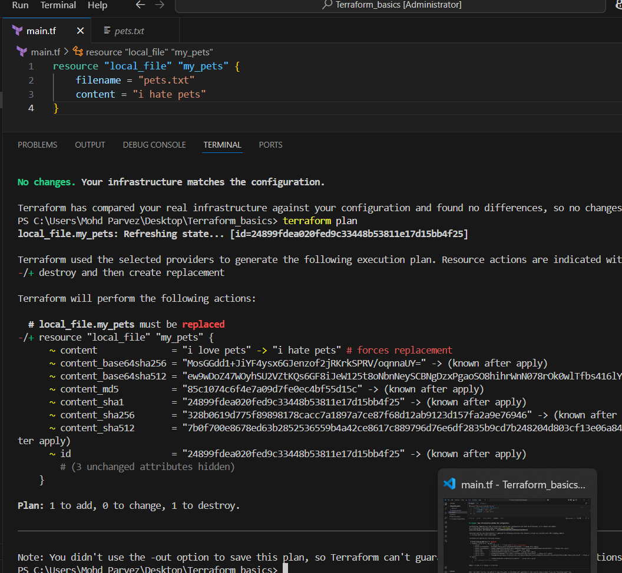
Here the
‘+’ create or add
‘~’ modify or change
‘-‘ destroy/ delete
Here I have made some changes it will show destroying and adding as “1”
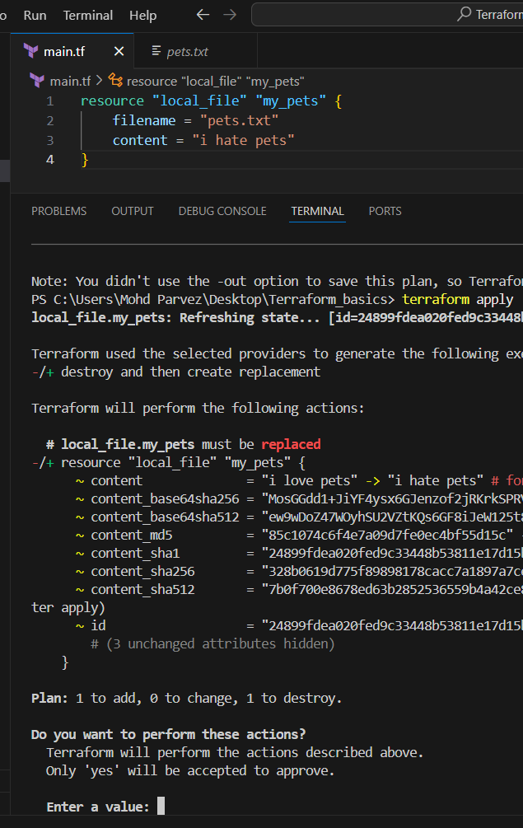
Add a random resource and do terraform plan it will not work
You need the dependencies for that
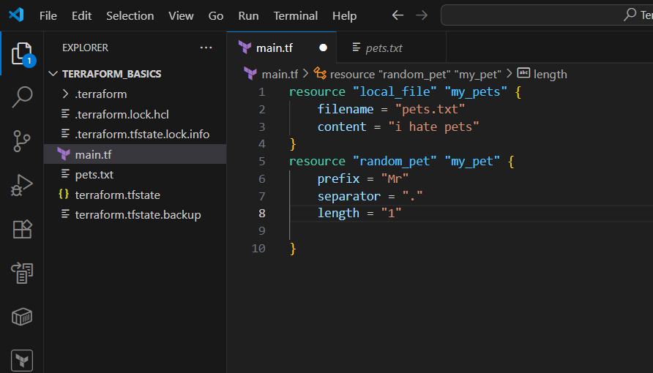
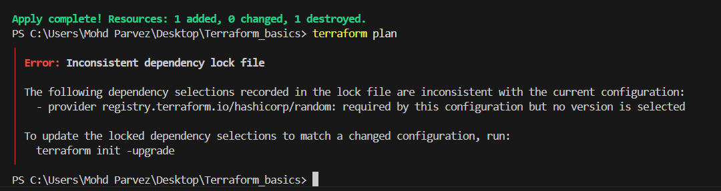
Again you need to apply the “terraform init” for downloading the dependencies
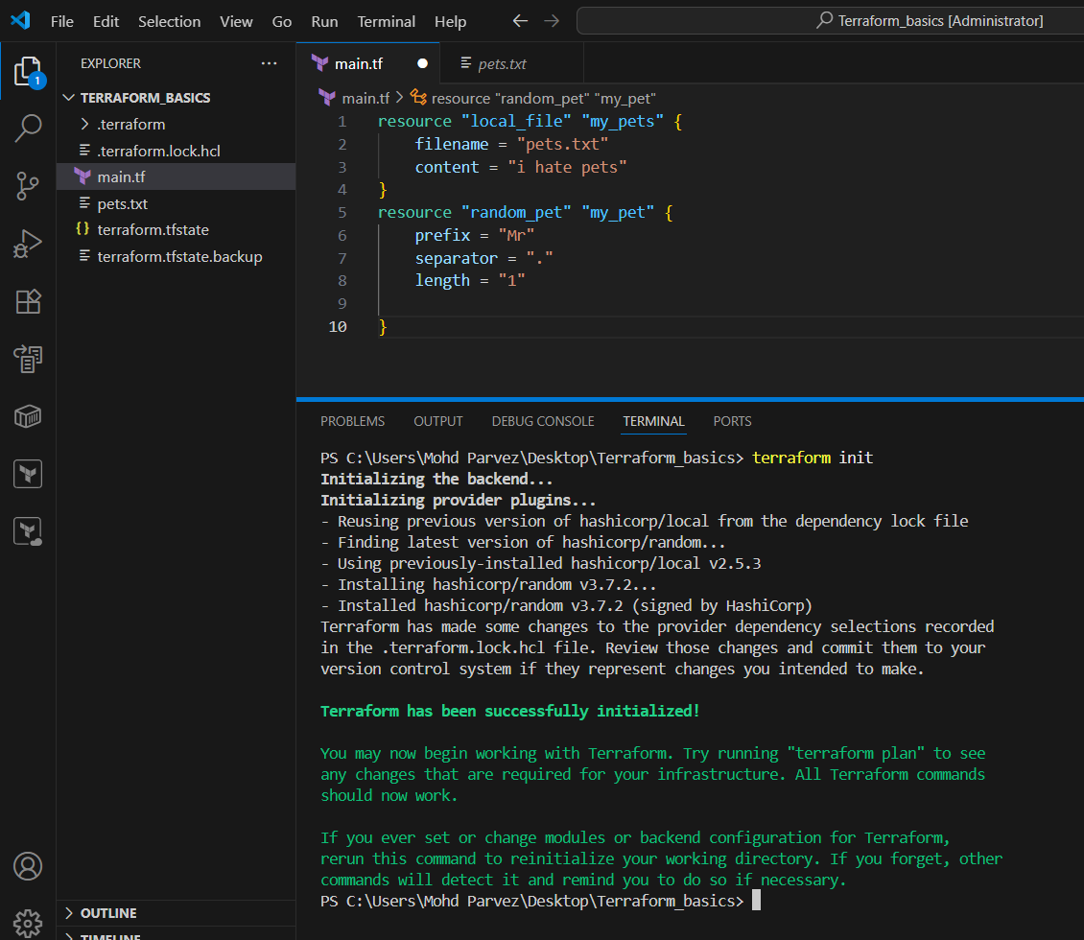
Now if you do terraform plan it will show the the context
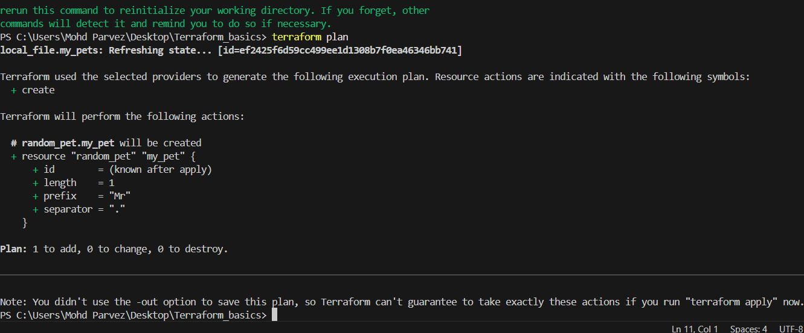
You can see the dependencies sre downloaded from providers
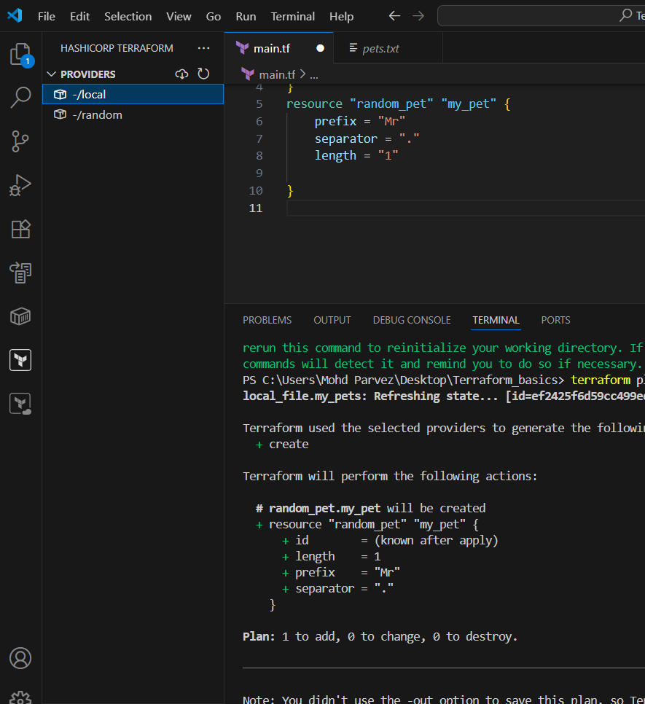
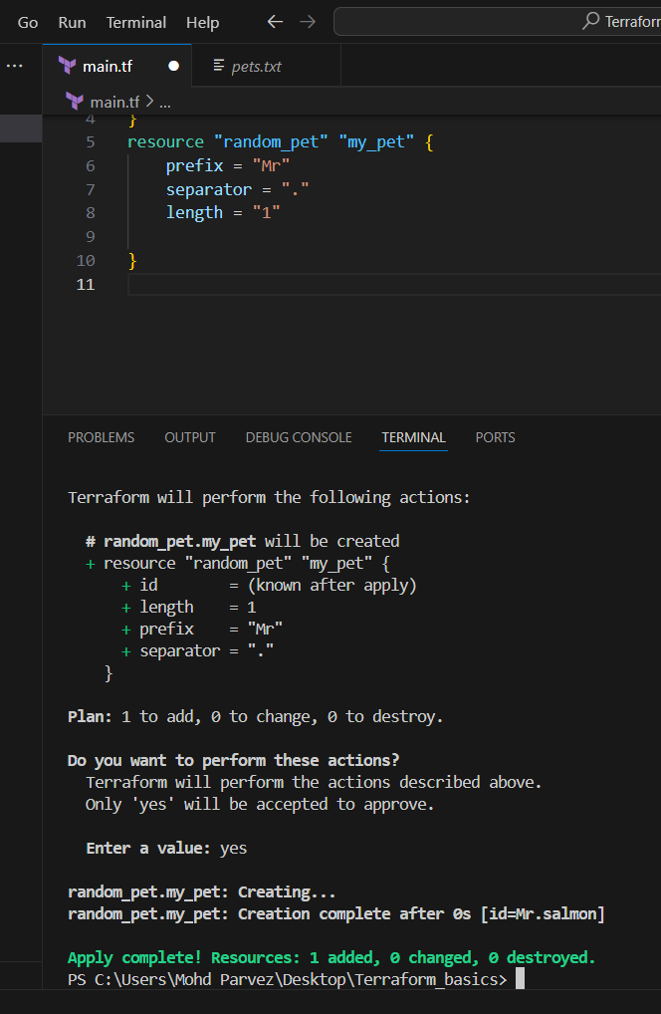
- You can also see the .tfstate file : is very important contains all information of the configuration from where It will checkthe file contexts



- NOTE DOWN BELOW POINTS, TERRAFORM INIT, TERRAFORM PLAN TERRAFORM APPLY TERRAFORM PROVIDER
1. TERRAFORM INIT
Purpose:
This command initializes your Terraform project.
Think of it like setting up your workspace before you start building anything.
What it does:
- Downloads the providers (like AWS, Azure, Google Cloud, etc.) that your configuration needs.
- Sets up the local .terraform directory to store Terraform files.
- Gets everything ready for other Terraform commands to work properly.
When to use it:
- Run this first when you create a new Terraform project.
- Also, run it again if you add or change a provider in your code.


- TERRAFORM PLAN:
Purpose:
This command shows what Terraform is going to do — without actually making any changes.
Think of it like a “preview” or “dry run.”
What it does:
- Looks at your configuration files (.tf files).
- Compares them to what’s already in your cloud infrastructure.
- Then shows you a list of what will be:
- Created
- Changed
- Destroyed
When to use it:
- Before you apply any changes — to make sure the plan looks right.



- TERRAFORM APPLY
Purpose:
This command actually builds or changes your infrastructure.
Think of it like pressing the “Go” button after checking your plan.
What it does:
- Executes the actions shown in the plan.
- Creates, updates, or deletes resources as needed.
- Saves the current state in a file called terraform.tfstate.
- The .tfstate file : is very important contains all information of the configuration from where It will check the file contexts.

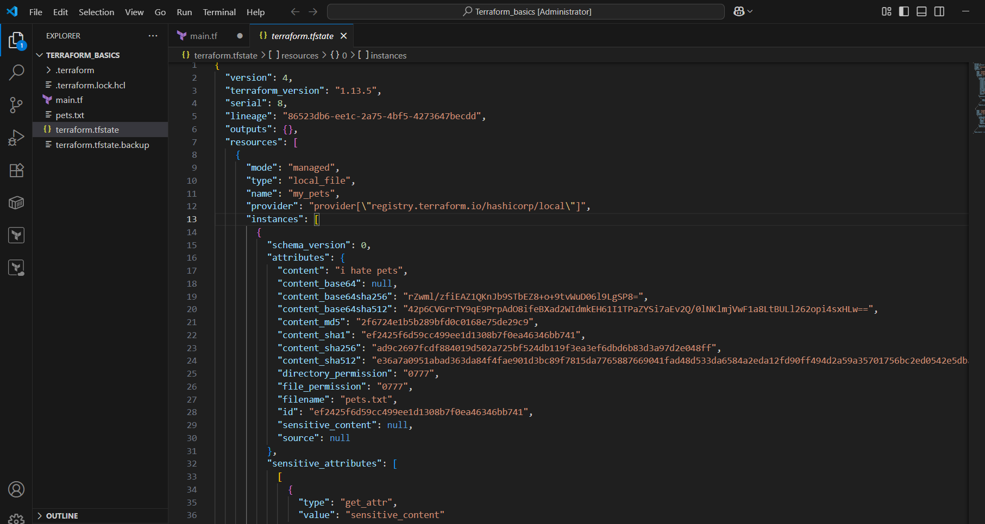

- TERRAFORM PROVIDER
Purpose:
A provider is what lets Terraform talk to a specific platform — like AWS, Azure, Google Cloud, GitHub, or even Docker.
Think of providers as “plugins” that know how to create resources in a specific service.
What happens during terraform init:
- Terraform downloads the correct version of each provider you define.
When to use or define providers:
- Every time you start a Terraform project.
- Whenever you want to use a new service (like adding Azure after AWS).
For example I have used “local” as provider
It downloads the dependencies of local resource
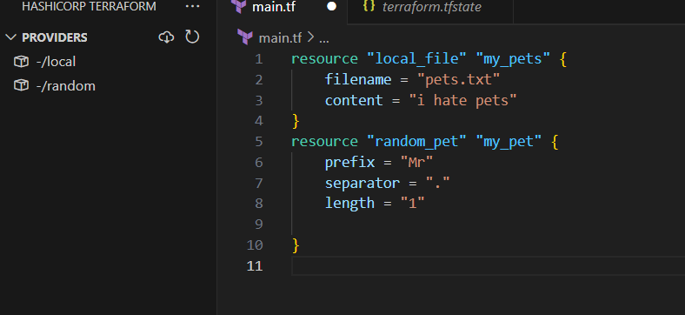

4.INTEGRATE A SAMPLE TERRAFORM TEMPLATE IN JENKINS
- launch an instance and connect to the instance and install Jenkins and start the Jenkins.
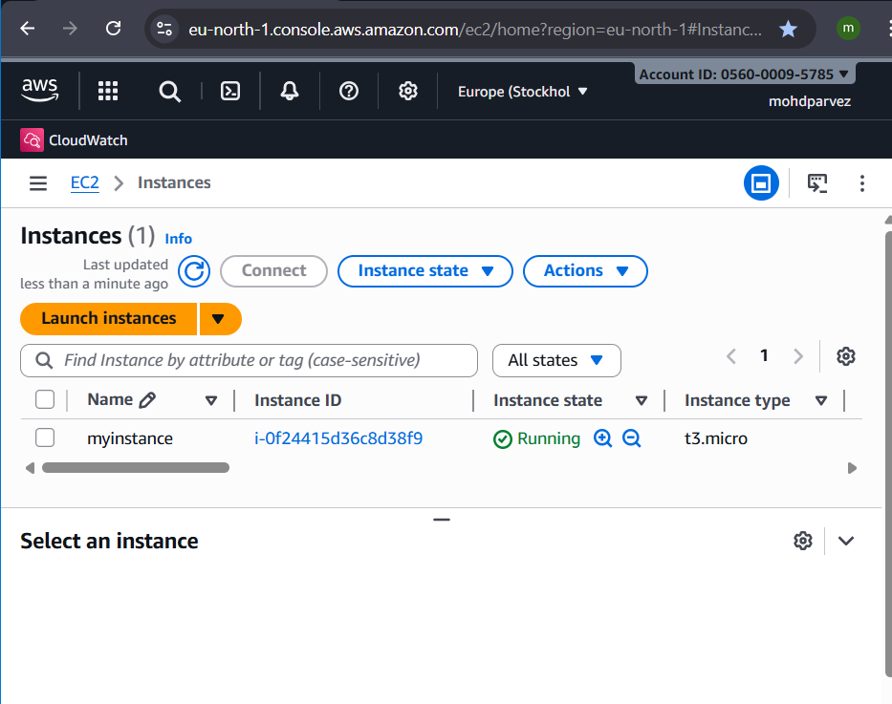
- install git in the server : yum install git
- verify by using command : git --version
- Git clone https://github.com/pmohd6065-ux/jenkinsdemo.git’
- This repository contains the file the main.tf which will launch the instance
- The pipe line in Jenkinsfile in repository has the pipe lie to install the terraform and run the terraform.

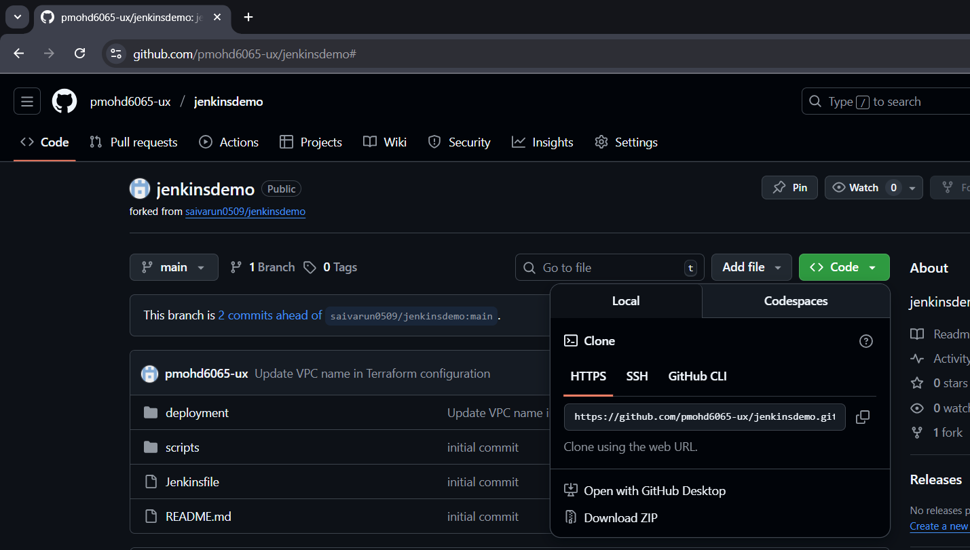

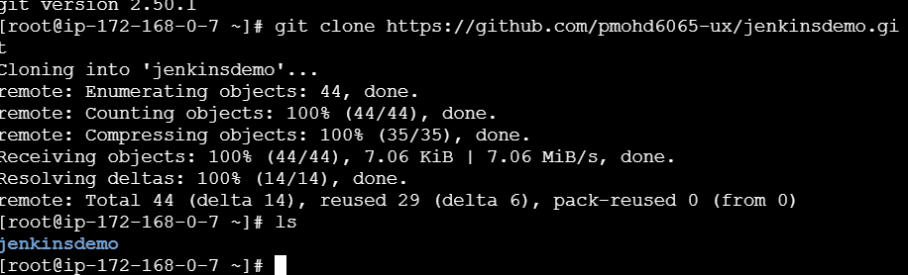
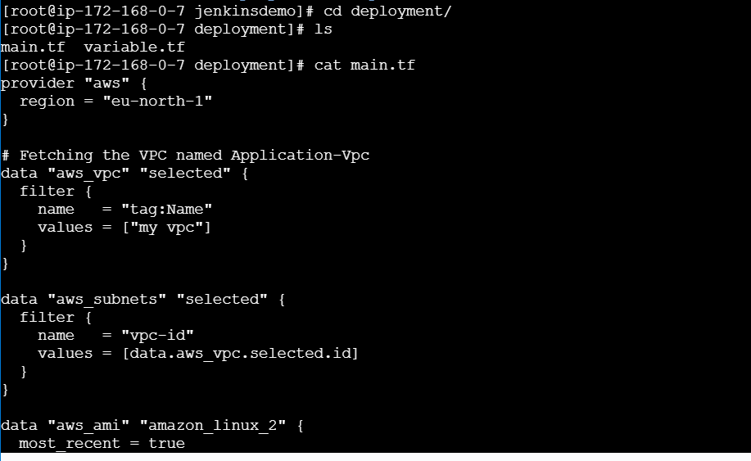
- Now go to the aws console and create role to acess the ec2 from Jenkins to launch ec2
- Create roleselectec2acess: select the administratoracesscreate role
- Ad drole to the instancegoto instances actionssecuritymodifyroleattach and update

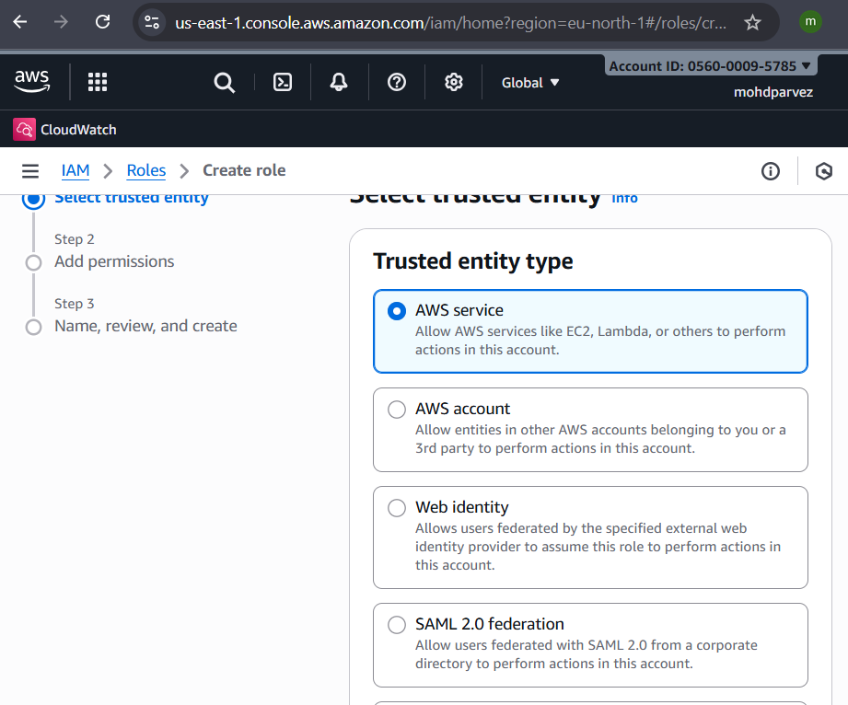

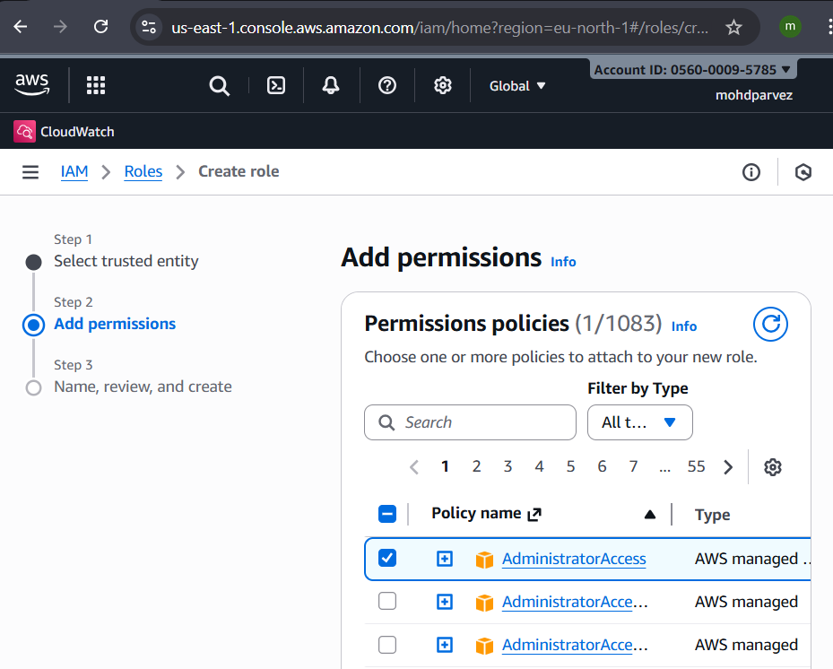
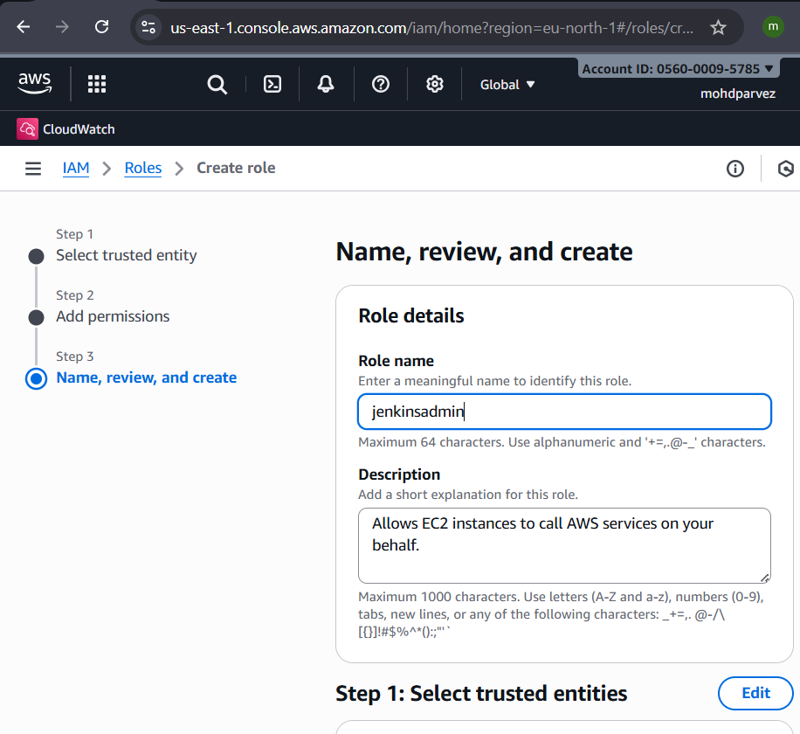

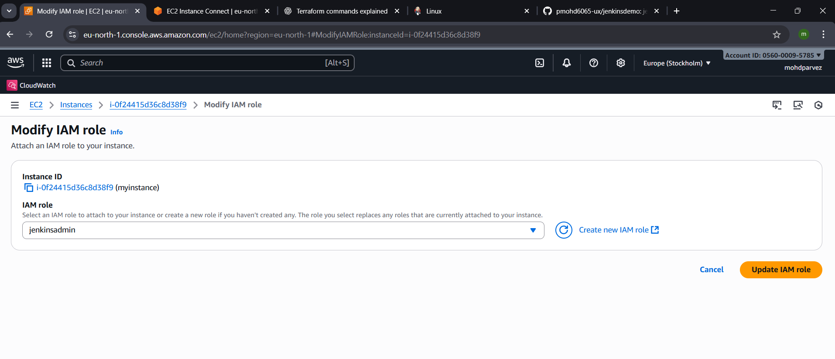

- Go to the Jenkins gui create jobselect pipelineconfigurepipeline select pipeline from scmselect the git provide git url and branch namescript path mention the file name where the terraform pipeline is thersave
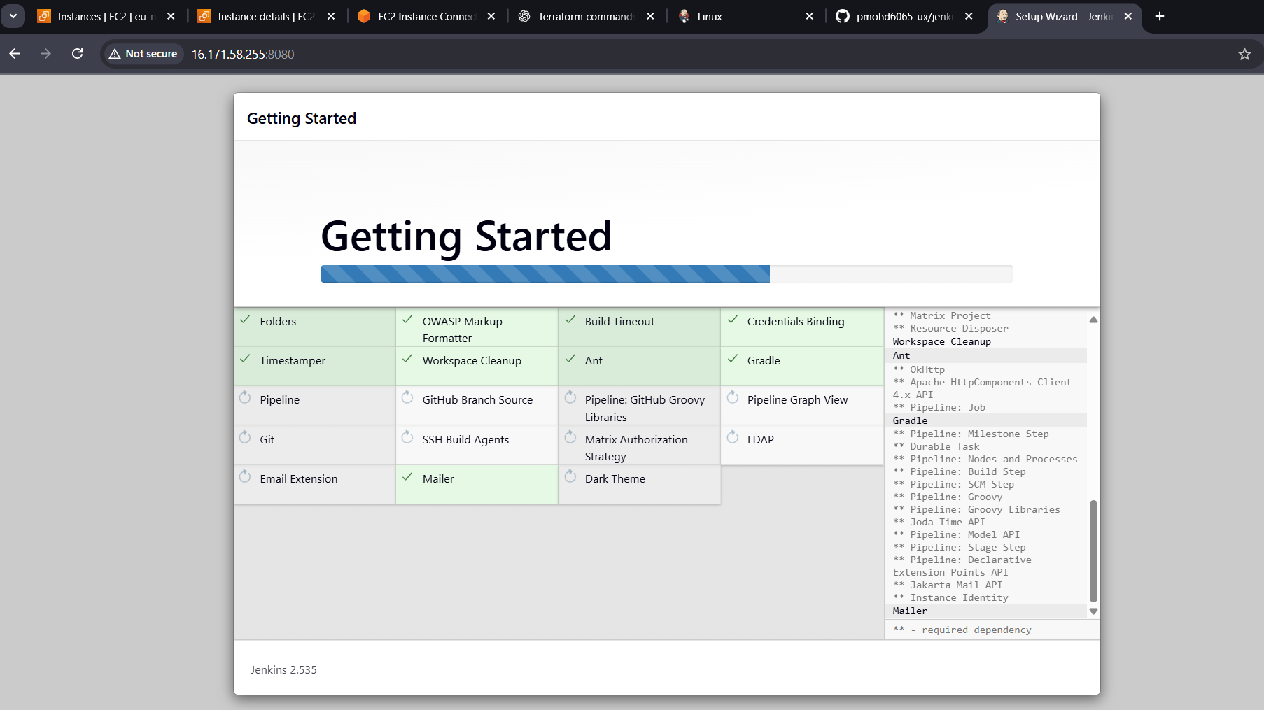
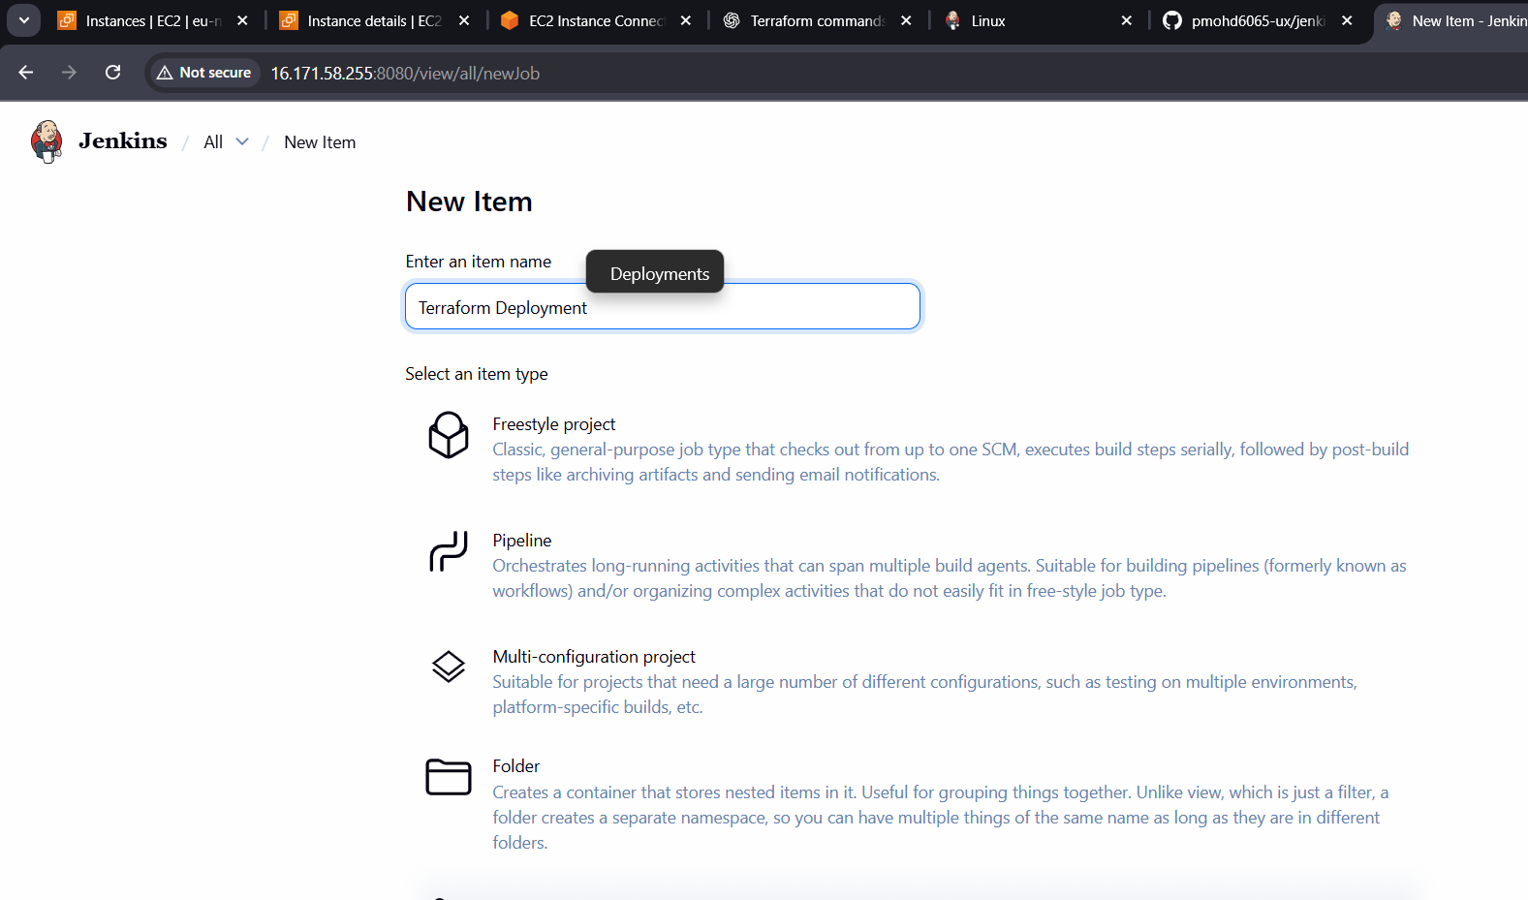

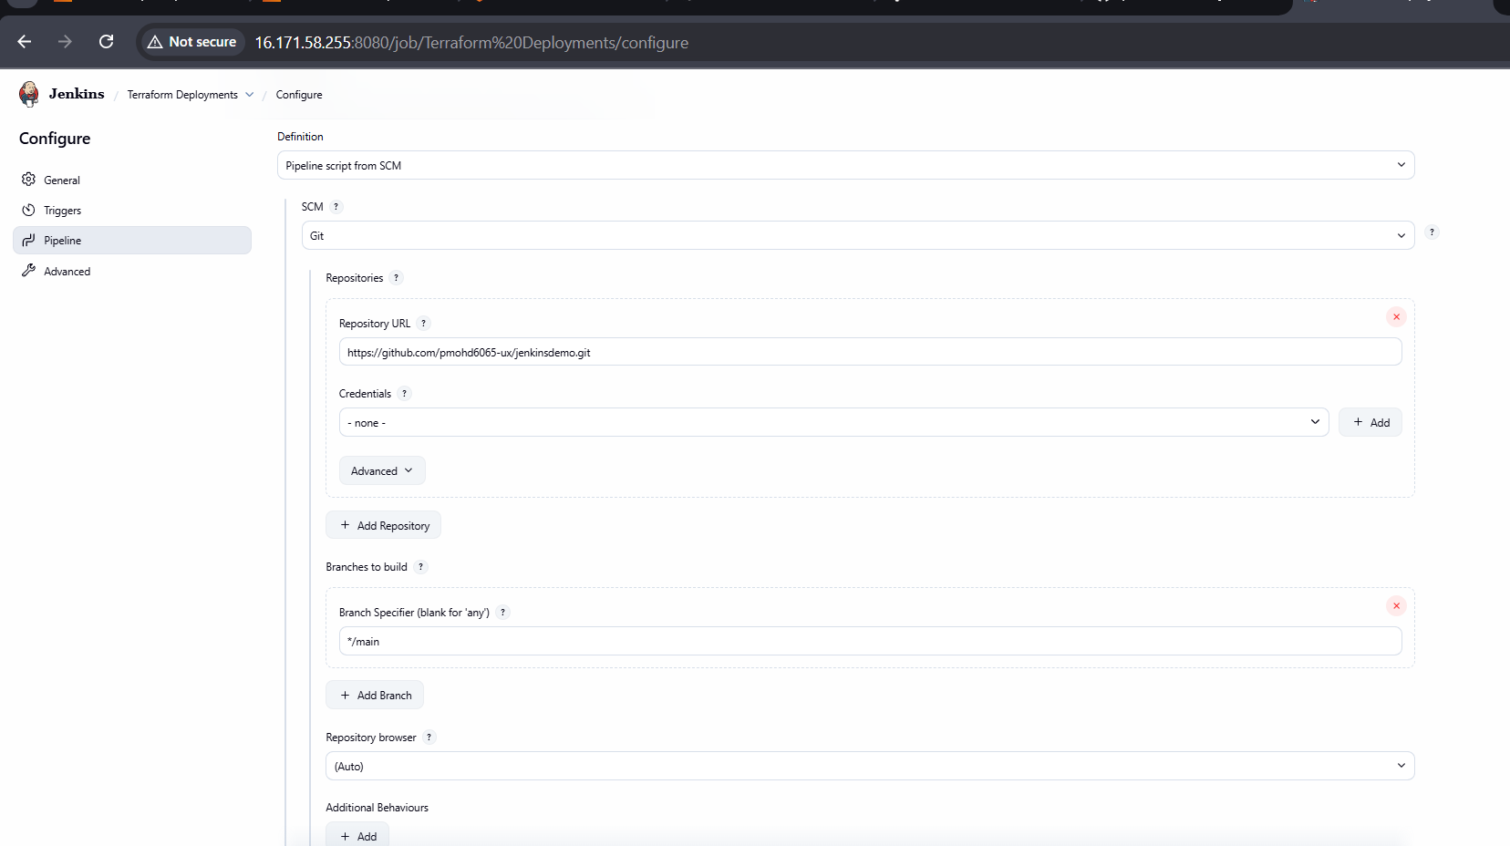

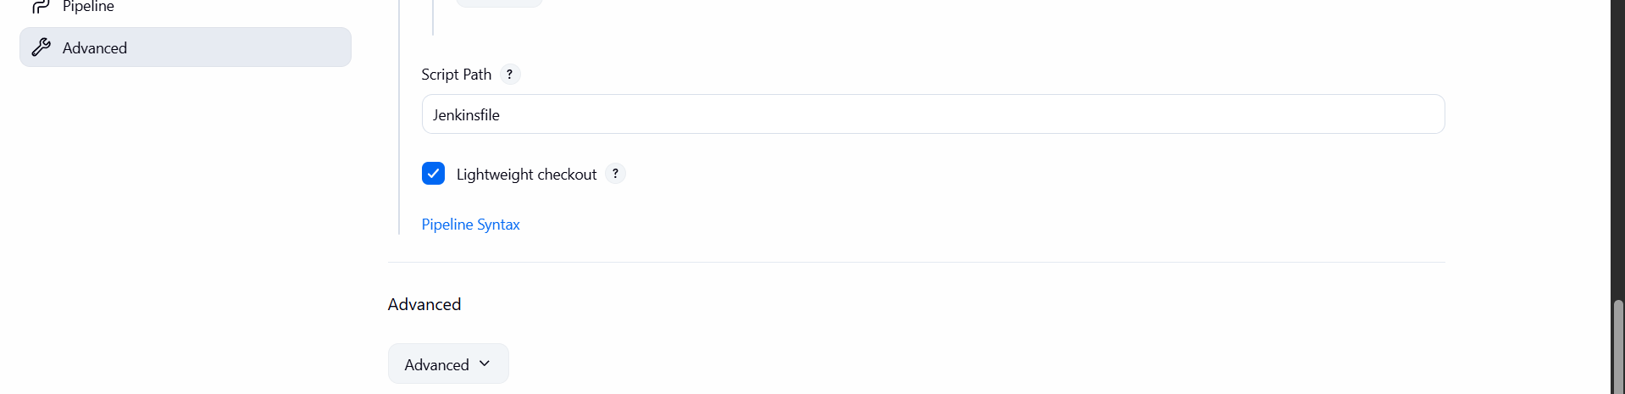

- Now go to the Jenkins cli edit the sudoers add the Jenkins with all permissions and no password
- Jenkins ALL=(ALL) NOPASSWD:ALL : paste this under the root
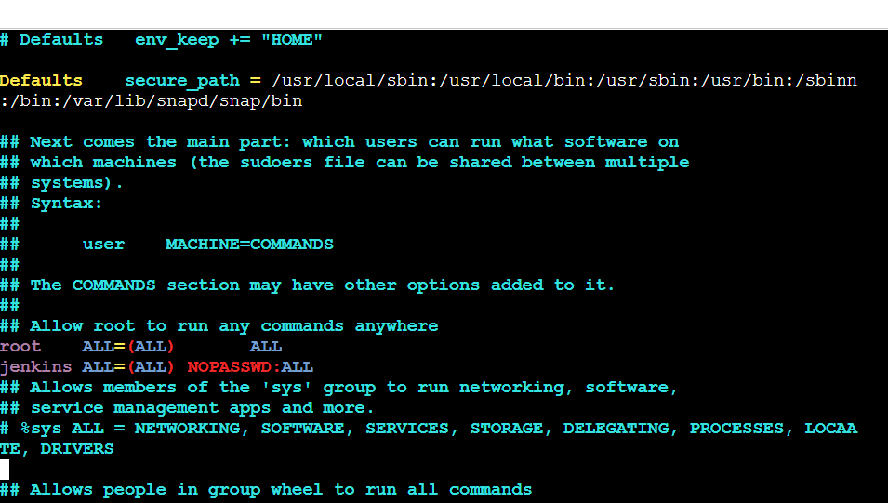
- now build the job in jenkinsgui

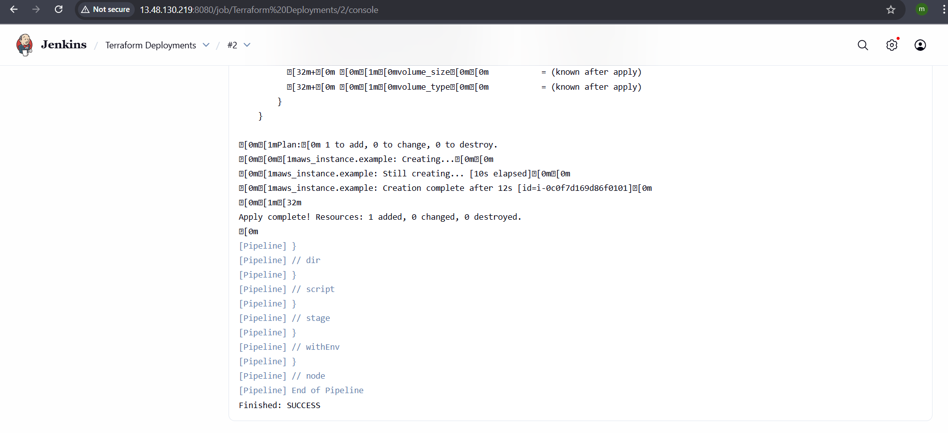
SUCESSFULLY LAUNCHED INSTANCE AND INSTALLED USING TERRAFORM AND PIPELINE

